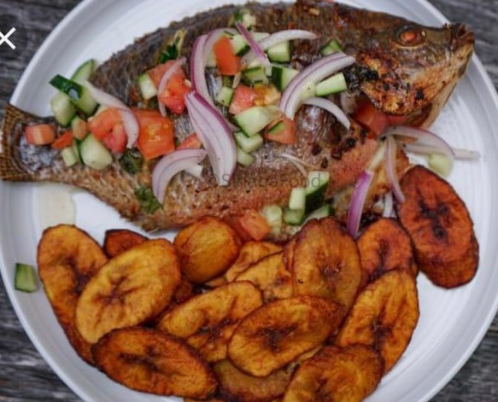
Whole Tilapia (fish) with Fried Plantain

- 2 whole tilapia

-4 plantain

-1 liter of oil

- 1 garlic bulb

- 1 lemon

- 1 Cucumber

- 2 tomatoes

- 1 onion

Fried plantain:

-peel the plantain, cut them in small circles,

-heat oil in a pan

-fry until they become brown

Tilapia 🐟:

- wash fish, and reheat oil

-after cleaning fish, rub salt, onion and garlic on it, then fry

Kachumare:

Cut tomatoes, onions, cucumbers, garlic and lemon, and mix together

